Assignment 1 Report

How to run the code:

This program is menu based, so you can browse the menu.

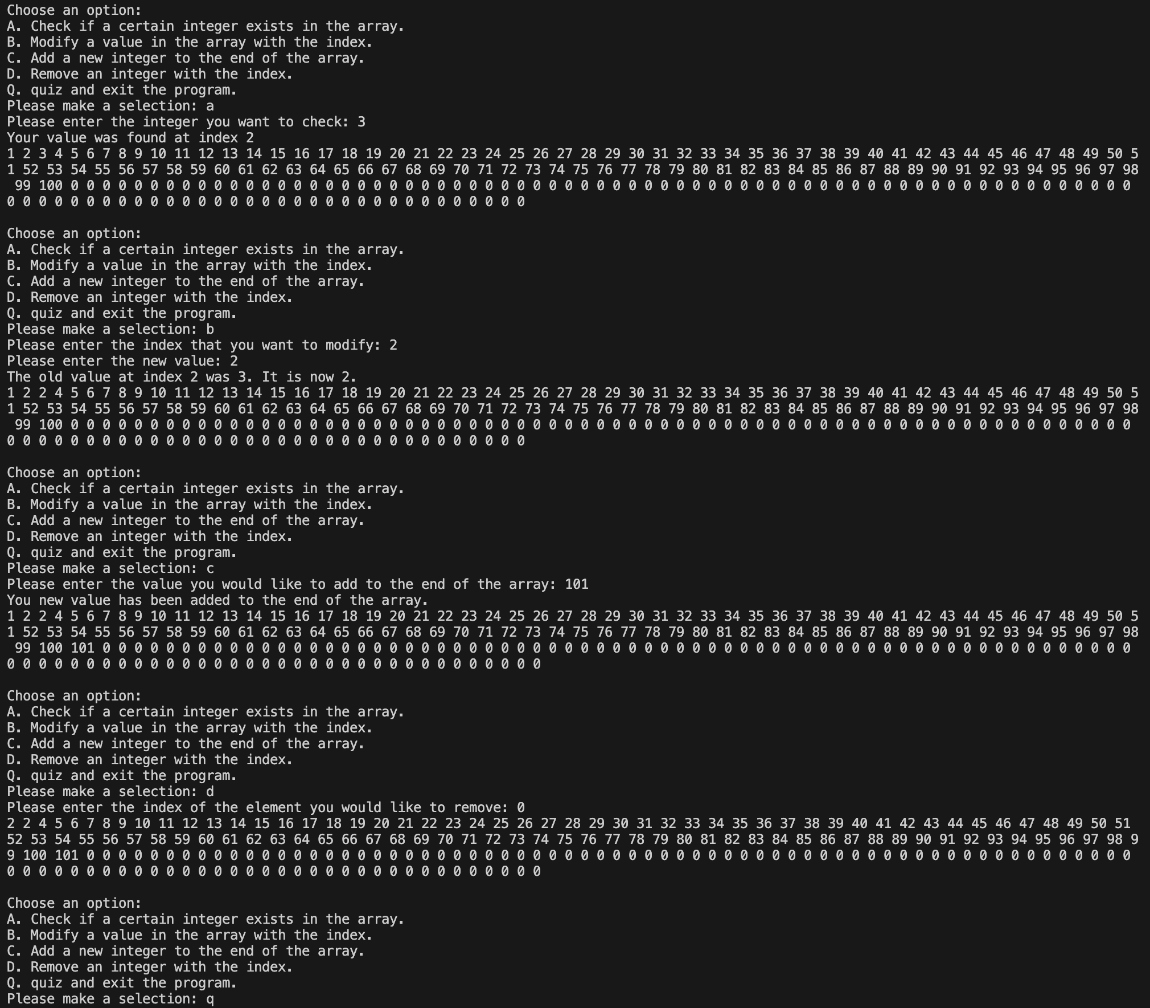Program Output Examples: